# User Guide

## Creating An Account

In order to create an account, you must specify what type of account you wish to create through the identification process (A – Admin, D – Doctor, S – Secretary, P – Patient) by writing the letter, and then . After this, fill in the rest of the details specified.

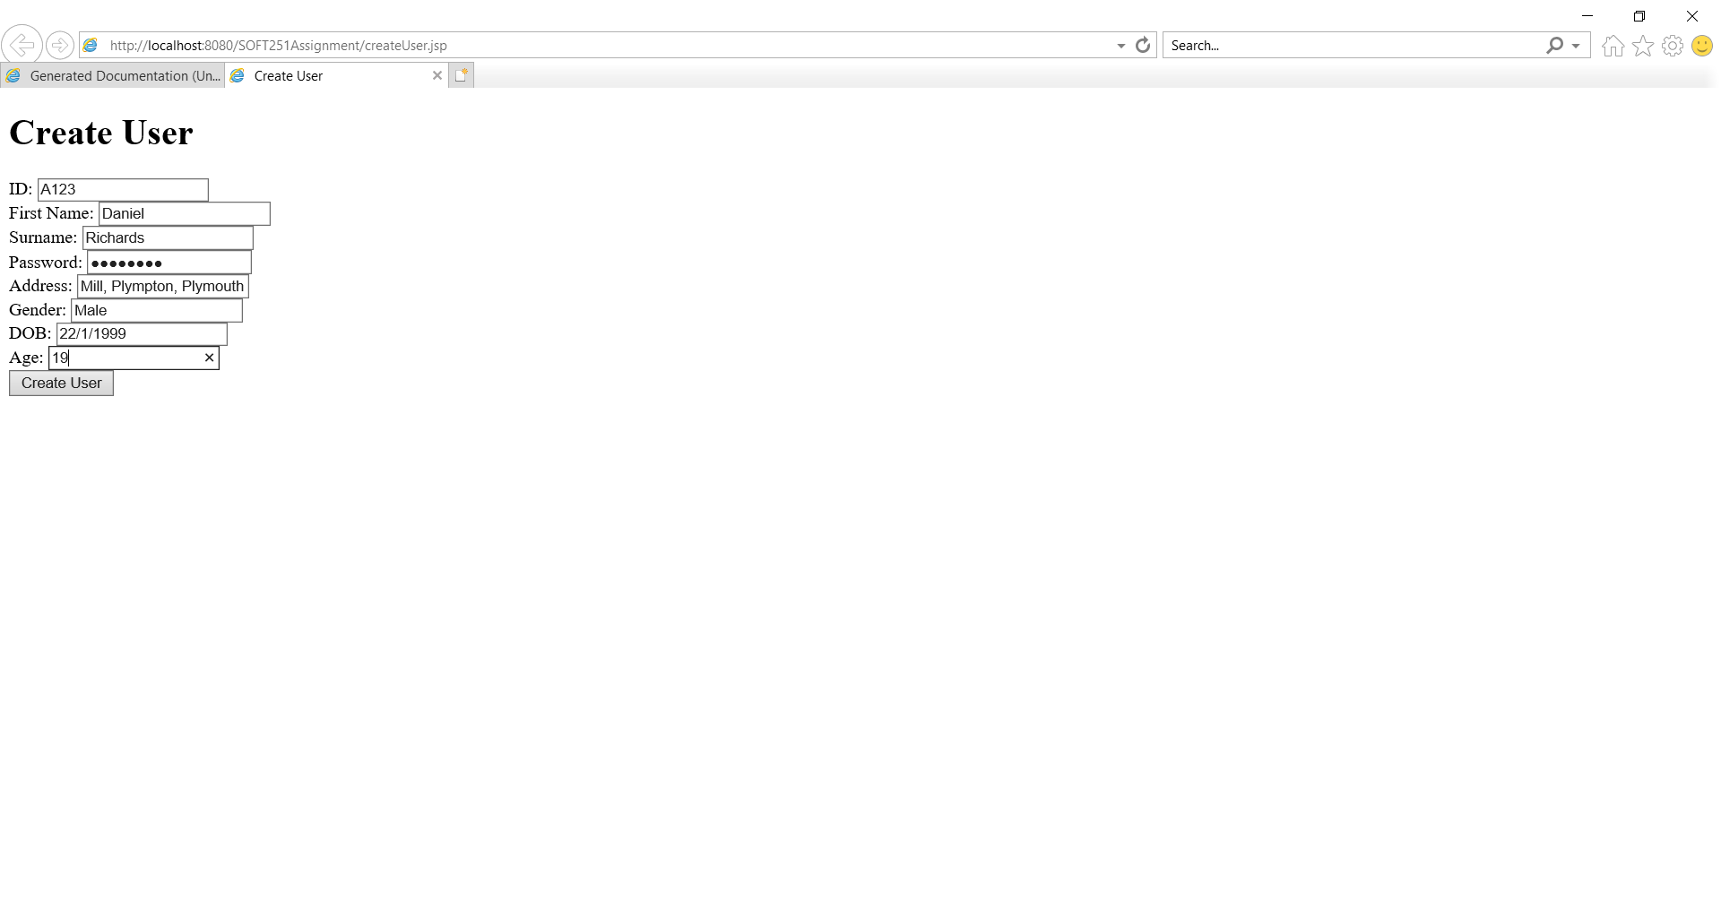

## Login

To login, simply input the User ID and password. You will be redirected to the appropriate dashboard.

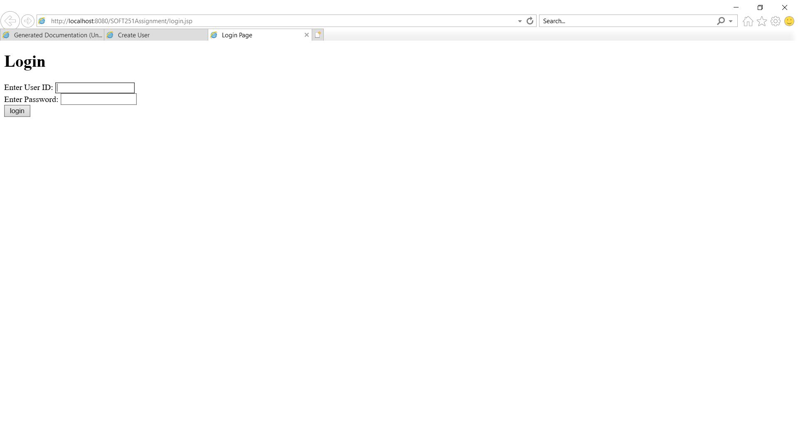

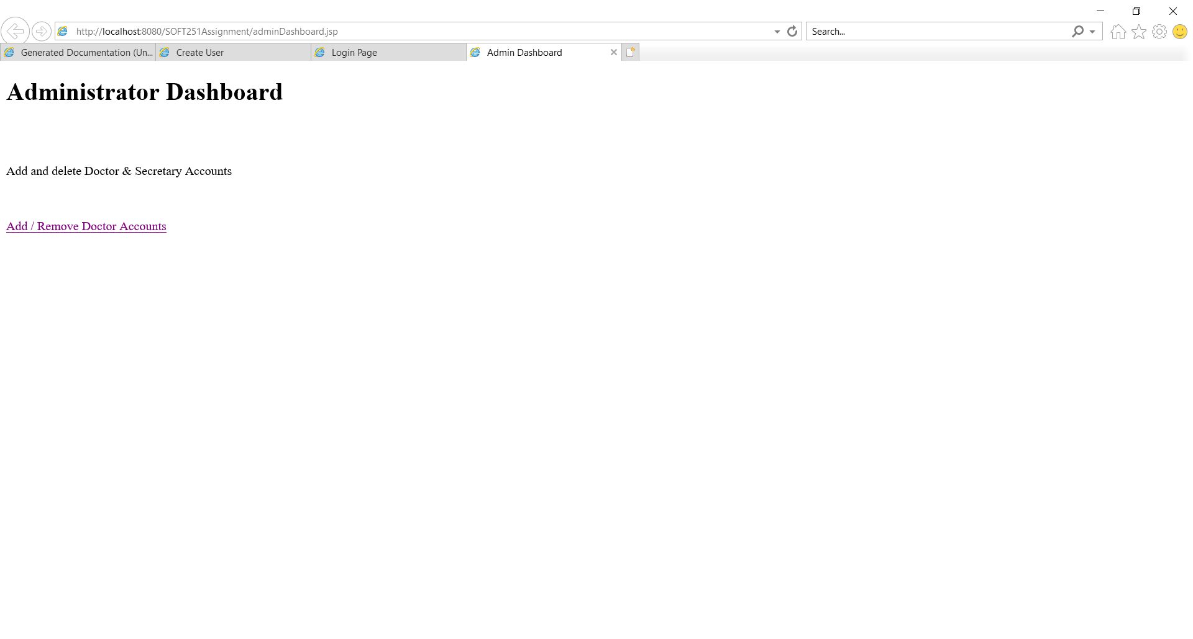

Admin Dashboard

## Rate Doctor

To rate a doctor, simply select the one you want to rate from the dropdown menu, and then select the amount of points you wish to give them. This will then be added to a score total, and divided by the amount of times they’ve been reviewed.